Chaos

Henri Poincaré
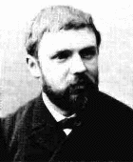
(April 29, 1854 - July 17, 1912)
Le savant n'étudie pas la nature parce que cela est utile; il l'étudie parce qu'il y prend plaisir et il y prend plaisir parce qu'elle est belle. Si la nature n'était pas belle, elle ne vaudrait pas la peine d'être connue, la vie ne vaudrait pas la peine d'être vécue.
- original French version of the quote on the main page
taken from Science et méthode

If nature were not beautiful, it would not be worth knowing, and if nature were not worth knowing, life would not be worth living
Jules H. Poincare

A very small cause which escapes our notice determines a considerable effect that we cannot fail to see, and then we say that the effect is due to chance.
Jules H. Poincare

1. Definition and History
2. Some real life examples
3. Some demonstrations
4. An example -- the logistic map
5. Second example to solve
6. Suggested reading material

1. Definition and History

Overview of noun chaos

The noun chaos has 3 senses

1. chaos, pandemonium, bedlam, topsy-turvydom, topsy-turvyness -- (a state of extreme confusion and disorder)
2. chaos -- (the formless and disordered state of matter before the creation of the cosmos)
3. Chaos -- ((Greek mythology) the most ancient of gods; the personification of the infinity of space preceding creation of the universe)

We will use the technical definition of a physicist or mathematician:
- sensitive dependence on initial conditions

Caveat that this should come out of dynamics for many points not just a special point.
Caveat, orbits should be bounded.

Comment on Newtonian Determinism
Story of the contest sponsored by the king of Sweden whose winner was a great mathematician Henry Poincare, considered by many to be the founder of Chaos Theory.
- in Henri Poincare’s own words:
“If we knew exactly the laws of nature and the situation of the universe at the initial moment, we could predict exactly the situation of that same universe at a succeeding moment. but even if it were the case that the natural laws had no longer any secret for us, we could still only know the initial situation approximately. If that enabled us to predict the succeeding situation with the same approximation, that is all we require, and we should say that the phenomenon had been predicted, that it is governed by laws. But it is not always so; it may happen that small differences in the initial conditions produce very great ones in the final phenomena. A small error in the former will produce an enormous error in the latter. Prediction becomes impossible, and we have the fortuitous phenomenon. - in a 1903 essay Science and Method.”

This has been followed by many other scientists and mathematicians.
Other early pioneering work in the field of chaotic dynamics is found in the mathematical literature by such luminaries as Birkhoff, Cartwright, Littlewood, Levinson, Smale, and Kolmogorov and their students. Work also by Figenbaum, Yorke, Grebogi, Heller, Ott and others.

Spread in different fields.
It is found that the ideas of chaos have been very fruitful in such diverse disciplines as biology, economics, chemistry, engineering, fluid mechanics, physics, just to name a few.

The modern technical use of the word “chaos” designated by Jim Yorke of U. of Maryland. Winner of the $400K Japan prize in 2003.

Rigorous definition: Initial small differences should grow exponentially,

dx(t) ~ dx(0)exp(bt).

2. Some examples:

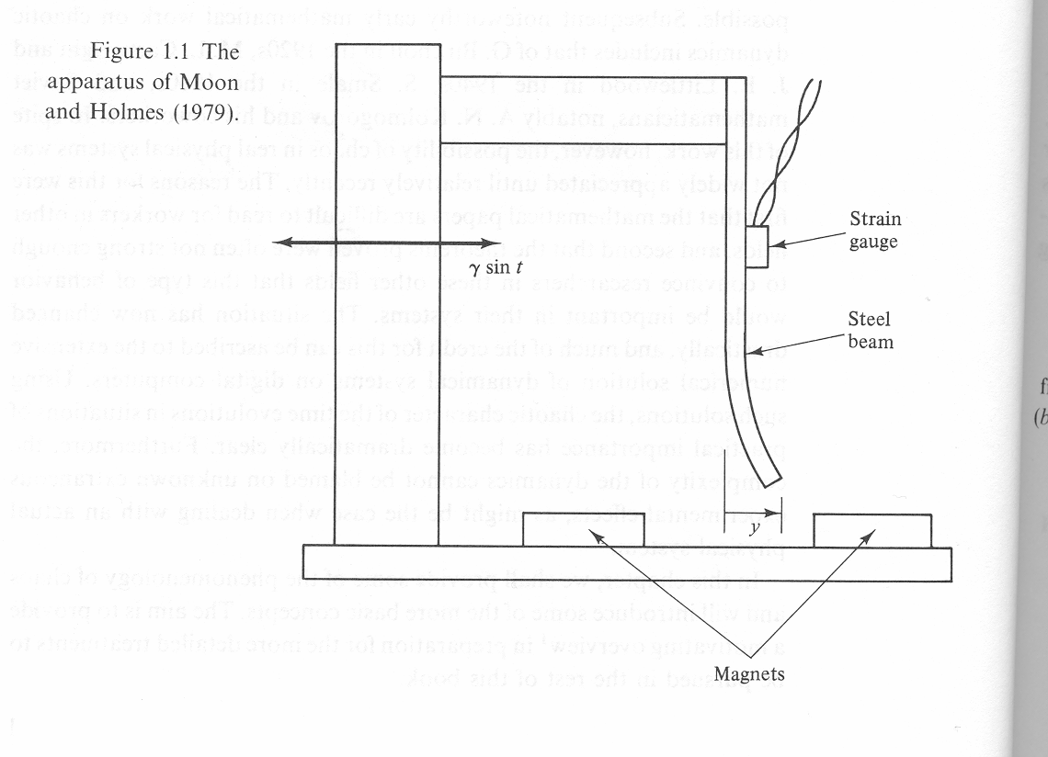
Steel rod in magnetic field in an oscillating apparatus.

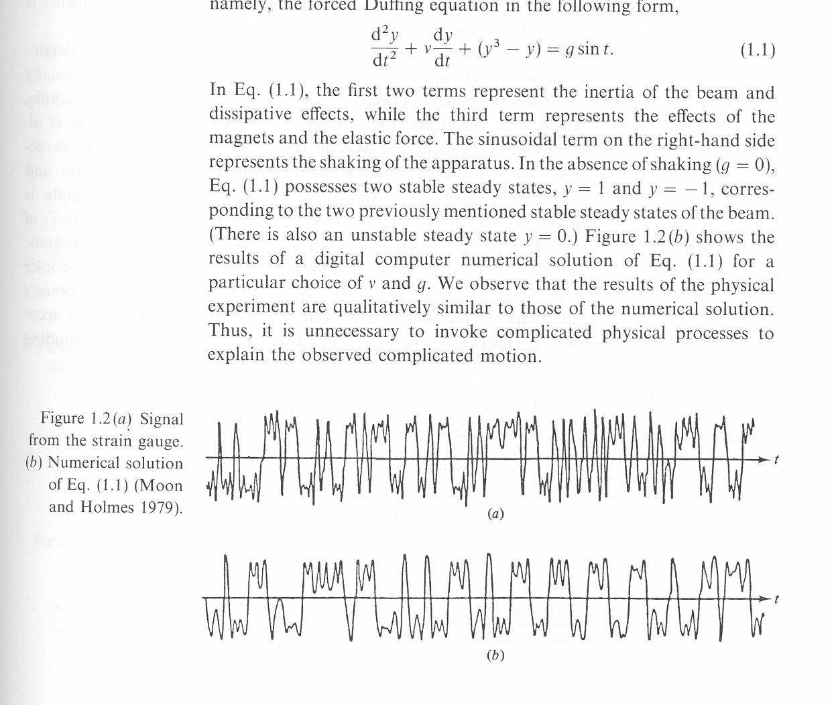

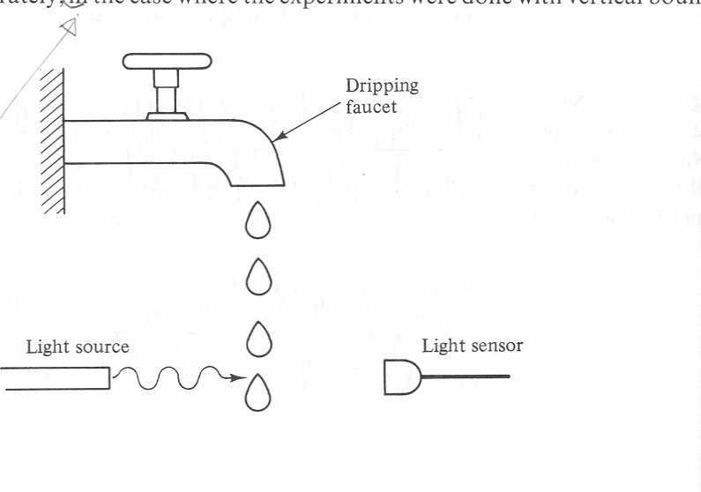

The time interval between successive drops is a function of the flow of water. For a small flow we get fixed time between drops. As flow increases different times that repeat in sequence happen. For much large flow the time intervals seem to be chaotic.

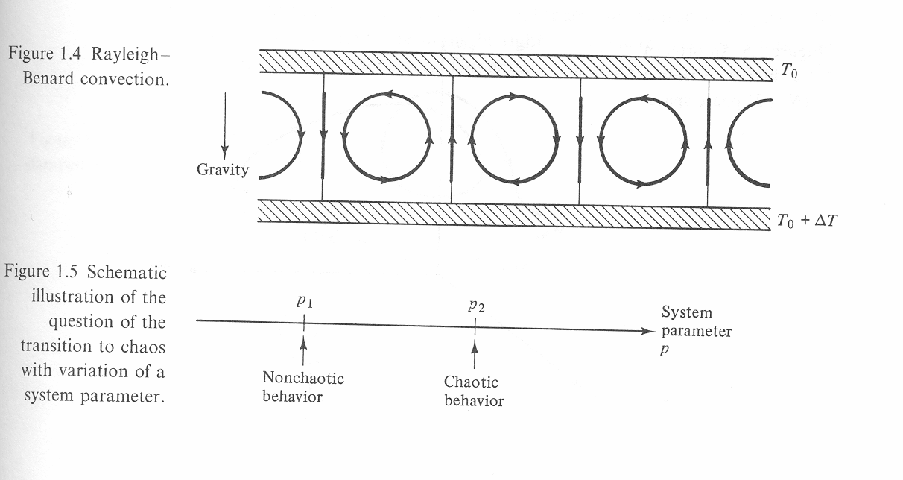

Depending on the temperature difference p = ΔT between upper and lower plates different flow dynamics is observed. Model for the system by Lorenz.

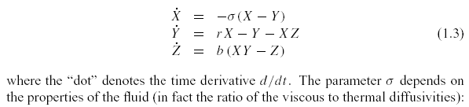
X is proportional to the circular fluid flow velocity. Y is the difference in the rising and falling fluid regions. Z is the distortion in the vertical temperature profile from its linear with height equilibrium value. Here are some demonstrations to illustrate the chaotic behavior.

3. Some demonstrations:

Applets showing sensitive dependence on initial conditions and parameters.

4. An example:

x_{n+1} = a x_{n} (1 – x_{n}), n = 0, 1, 2, …..

x_{n} is an insect population on an island with limited food resources in the n^{th} year.
The dynamics becomes fractal for a = 4.

5. Second example to solve:

Tent map

x_{n+1} = 1 - |2x_{n} - 1|, n = 0, 1, 2, …..

Solve for 10 iterations. Start with x0 = 0.1, 0.11, 0.09. Observe the exponential dependence on initial conditions.

6. Reading material:

http://www.cmp.caltech.edu/~mcc/Chaos_Course/Outline.html
http://archives.math.utk.edu/topics/nonlinearDynamics.html

